Report - Assignments 1

# General Info

Team Members:

1. Guy Shitrit (204711576) – shitritg@post.bgu.ac.il
2. Ofir Dvir (308293950) – ofirdvi@post.bgu.ac.il
3. Assaf Nahum () – assafna@post.bgu.ac.il
4. Noam Moscovich () – noammosc@post.bgu.ac.il

EC Tool:

1. Python DEAP - <https://deap.readthedocs.io/en/master/api/tools.html>

# eVOLUTIONARY ALGORITHM PARAMENERS - SUMMARY

In these experiments, we run five different configurations as follow:

Round 1:

|  |  |
| --- | --- |
| Representation | Array |
| Recombination | single point crossover |
| Recombination probability | 70% |
| Mutation | one point mutation |
| Mutation probability | 0.1% |
| Parent selection |  |
| Survival selection | roulette-wheel sampling |
| Population size | 100 |
| Initialization | random |
| Termination conditions | Creation of 100 generation |

Round 2:

|  |  |
| --- | --- |
| Representation | Permutation |
| Recombination | Partially Matched |
| Recombination probability | 40% |
| Mutation | Two values random swapping |
| Mutation probability | 0.1% |
| Parent selection |  |
| Survival selection | roulette-wheel sampling |
| Population size | 100 |
| Initialization | random |
| Termination conditions | Creation of 100 generation |

Round 3:

|  |  |
| --- | --- |
| Representation | Permutation |
| Recombination | Partially Matched |
| Recombination probability | 10% |
| Mutation | Two values random swapping |
| Mutation probability | 0.1% |
| Parent selection |  |
| Survival selection | roulette-wheel sampling |
| Population size | 100 |
| Initialization | random |
| Termination conditions | Creation of 100 generation |

Round 4:

|  |  |
| --- | --- |
| Representation | Permutation |
| Recombination | Partially Matched |
| Recombination probability | 70% |
| Mutation | Two values random swapping |
| Mutation probability | 1% |
| Parent selection |  |
| Survival selection | roulette-wheel sampling |
| Population size | 100 |
| Initialization | random |
| Termination conditions | Creation of 100 generation |

Round 3:

|  |  |
| --- | --- |
| Representation | Permutation |
| Recombination | Partially Matched |
| Recombination probability | 70% |
| Mutation | Two values random swapping |
| Mutation probability | 10% |
| Parent selection |  |
| Survival selection | roulette-wheel sampling |
| Population size | 100 |
| Initialization | random |
| Termination conditions | Creation of 100 generation |

# pROCESS OF WORK

We chose to implement our code with a package called DEAP in Python, which contains most of the functions we were required to use.

However, In order to fulfill the assignment requirements, we added two functions ourselves:

1. **evaluateFunc**: calculates the fitness score for each individual.

The fitness score represents the amount of conflicts that each individual has. Therefore, the best individual is represented by the minimum score (min fitness).

Hence, the lower the score means the individual represents a possibility that is closer to solving the 8 Queens problem.

Conflicts calculation - In the assignment we were asked to represent individuals in two different methods: array or permutation. Due to the differences that exist between the two (in array representation there can be repetitions), the number of conflicts calculated differently for each representation.

When for permutations, conflicts were calculated in diagonals only, whereas in arrays, conflicts were calculated in both diagonals and rows.

1. **createMutate:**

Similar to the conflicts calculation, the mutation generation method was also different between the two types of representations. When for arrays we used ‘one point mutate’ method as requested in the assignment and for permutations we used the ‘two point swapping’ as we learned in the lecture.

As part of the work process, we noticed that the results obtained were not as good as we wanted. And as part of the code review process, we examined the use of various functions to understand whether it was our error or were they indeed the correct results, and we noticed that the main cause of the problematic results was the method of choice that we were asked to use in this assignment (roulette-wheel sampling).

It is clear to us that there are other parameters that affected the results we have received but it is the parameter that made the most significant change in the results. Attached to the Appendices five graphs that describe experiments results while using ‘Tournament’ as selection function.

# RESULTS

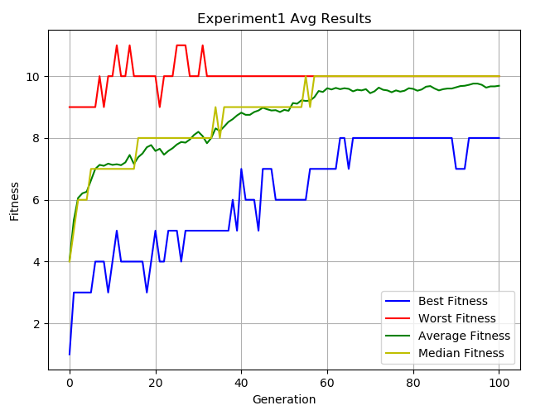 Experiment 1:

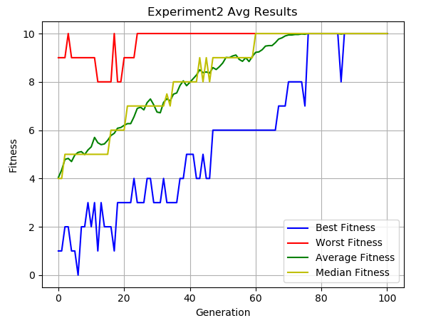Experiment 2:

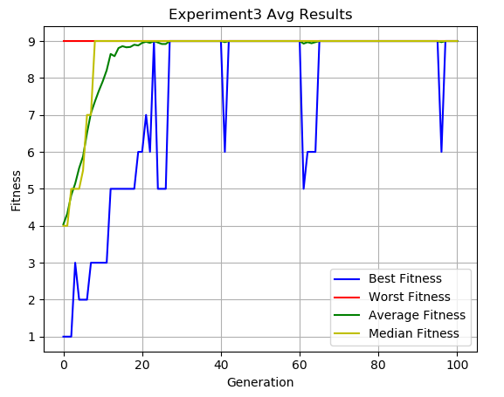

Experiment 3:

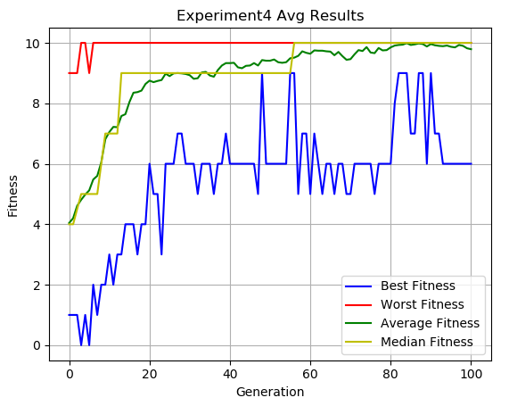Experiment 4:

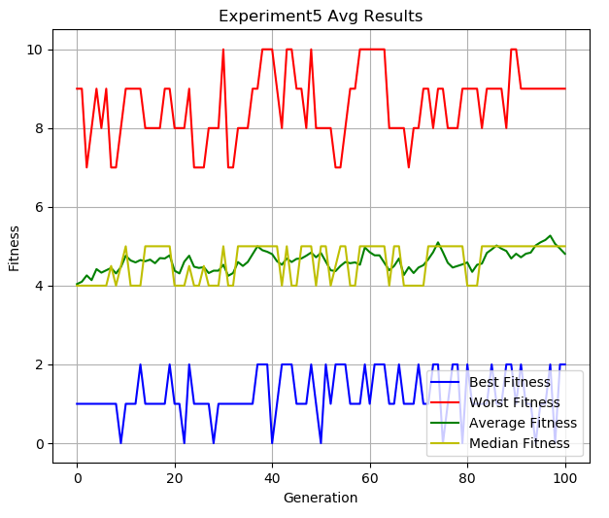Experiment 5:

# CONCLUSIONS

1. The solution that was found is not the optimal solution. This is because the algorithm continued to execute instead of stopping when it found the optimal solution. In this case, it was necessary to add to the termination condition that if an optimal solution is found (i.e., no conflicts between the queens) the algorithm execution should be terminate.
2. The selection method we use results in reaching a local maximum. Using a different selection method significantly improves our results
3. Using permutation is more suits to the queen problem than using array because it reduces the problem. We need to find conflicts on diagonals only because we do not create invalid individuals in the first place (which has repetitions, i.e. the placement of two queens in the same row) and therefore it optimizes the algorithm.
4. In Experiment # 3, we got the worst results. We assume that this is because in this experiment the probabilities for mutation and crossover are really low. As there are more changes in individuals the algorithm can reach to a better population. Accordingly, in Experiment # 5, we got the best results thanks to the high probabilities for mutation and crossover.

# FUTURE WORK

1. Perform the experiment with a termination condition that relates to the optimal solution - that is, let the algorithm execute up to 100 generations **or** until the optimal solution is found
2. Performing the experiment with a more efficient and suitable selection function such as a tournament can produce better results than performing it with the roulette-wheel sampling function

# Appendices

**The average results of the experiments per generation:**

Experiment 1:

|  |  |  |  |  |
| --- | --- | --- | --- | --- |
| Generation | Best Fitness | Worst Fitness | Average Fitness | Median Fitness |
| 0 | 1 | 9 | 4.04 | 4 |
| 1 | 3 | 9 | 5.34 | 5 |
| 2 | 3 | 9 | 6.06 | 6 |
| 3 | 3 | 9 | 6.21 | 6 |
| 4 | 3 | 9 | 6.26 | 6 |
| 5 | 3 | 9 | 6.63 | 7 |
| 6 | 4 | 9 | 7 | 7 |
| 7 | 4 | 10 | 7.13 | 7 |
| 8 | 4 | 9 | 7.1 | 7 |
| 9 | 3 | 10 | 7.17 | 7 |
| 10 | 4 | 10 | 7.13 | 7 |
| 11 | 5 | 11 | 7.15 | 7 |
| 12 | 4 | 10 | 7.12 | 7 |
| 13 | 4 | 10 | 7.21 | 7 |
| 14 | 4 | 11 | 7.45 | 7 |
| 15 | 4 | 10 | 7.16 | 7 |
| 16 | 4 | 10 | 7.38 | 8 |
| 17 | 4 | 10 | 7.5 | 8 |
| 18 | 3 | 10 | 7.7 | 8 |
| 19 | 4 | 10 | 7.77 | 8 |
| 20 | 5 | 10 | 7.58 | 8 |
| 21 | 4 | 9 | 7.65 | 8 |
| 22 | 4 | 10 | 7.46 | 8 |
| 23 | 5 | 10 | 7.58 | 8 |
| 24 | 5 | 10 | 7.67 | 8 |
| 25 | 5 | 11 | 7.79 | 8 |
| 26 | 4 | 11 | 7.87 | 8 |
| 27 | 5 | 11 | 7.85 | 8 |
| 28 | 5 | 10 | 7.95 | 8 |
| 29 | 5 | 10 | 8.1 | 8 |
| 30 | 5 | 10 | 8.2 | 8 |
| 31 | 5 | 11 | 8.06 | 8 |
| 32 | 5 | 10 | 7.83 | 8 |
| 33 | 5 | 10 | 8 | 8 |
| 34 | 5 | 10 | 8.31 | 9 |
| 35 | 5 | 10 | 8.23 | 8 |
| 36 | 5 | 10 | 8.37 | 9 |
| 37 | 5 | 10 | 8.52 | 9 |
| 38 | 6 | 10 | 8.61 | 9 |
| 39 | 5 | 10 | 8.73 | 9 |
| 40 | 7 | 10 | 8.82 | 9 |
| 41 | 6 | 10 | 8.75 | 9 |
| 42 | 6 | 10 | 8.75 | 9 |
| 43 | 6 | 10 | 8.84 | 9 |
| 44 | 5 | 10 | 8.89 | 9 |
| 45 | 7 | 10 | 8.98 | 9 |
| 46 | 7 | 10 | 8.93 | 9 |
| 47 | 7 | 10 | 8.89 | 9 |
| 48 | 6 | 10 | 8.9 | 9 |
| 49 | 6 | 10 | 8.84 | 9 |
| 50 | 6 | 10 | 8.91 | 9 |
| 51 | 6 | 10 | 8.88 | 9 |
| 52 | 6 | 10 | 9.13 | 9 |
| 53 | 6 | 10 | 9.11 | 9 |
| 54 | 6 | 10 | 9.22 | 9 |
| 55 | 6 | 10 | 9.2 | 10 |
| 56 | 7 | 10 | 9.21 | 9 |
| 57 | 7 | 10 | 9.32 | 10 |
| 58 | 7 | 10 | 9.52 | 10 |
| 59 | 7 | 10 | 9.49 | 10 |
| 60 | 7 | 10 | 9.61 | 10 |
| 61 | 7 | 10 | 9.57 | 10 |
| 62 | 7 | 10 | 9.62 | 10 |
| 63 | 8 | 10 | 9.58 | 10 |
| 64 | 8 | 10 | 9.61 | 10 |
| 65 | 7 | 10 | 9.59 | 10 |
| 66 | 8 | 10 | 9.51 | 10 |
| 67 | 8 | 10 | 9.56 | 10 |
| 68 | 8 | 10 | 9.54 | 10 |
| 69 | 8 | 10 | 9.58 | 10 |
| 70 | 8 | 10 | 9.45 | 10 |
| 71 | 8 | 10 | 9.51 | 10 |
| 72 | 8 | 10 | 9.63 | 10 |
| 73 | 8 | 10 | 9.56 | 10 |
| 74 | 8 | 10 | 9.54 | 10 |
| 75 | 8 | 10 | 9.48 | 10 |
| 76 | 8 | 10 | 9.54 | 10 |
| 77 | 8 | 10 | 9.5 | 10 |
| 78 | 8 | 10 | 9.53 | 10 |
| 79 | 8 | 10 | 9.61 | 10 |
| 80 | 8 | 10 | 9.59 | 10 |
| 81 | 8 | 10 | 9.53 | 10 |
| 82 | 8 | 10 | 9.57 | 10 |
| 83 | 8 | 10 | 9.66 | 10 |
| 84 | 8 | 10 | 9.68 | 10 |
| 85 | 8 | 10 | 9.6 | 10 |
| 86 | 8 | 10 | 9.54 | 10 |
| 87 | 8 | 10 | 9.58 | 10 |
| 88 | 8 | 10 | 9.6 | 10 |
| 89 | 8 | 10 | 9.6 | 10 |
| 90 | 7 | 10 | 9.64 | 10 |
| 91 | 7 | 10 | 9.68 | 10 |
| 92 | 7 | 10 | 9.69 | 10 |
| 93 | 8 | 10 | 9.72 | 10 |
| 94 | 8 | 10 | 9.76 | 10 |
| 95 | 8 | 10 | 9.76 | 10 |
| 96 | 8 | 10 | 9.72 | 10 |
| 97 | 8 | 10 | 9.63 | 10 |
| 98 | 8 | 10 | 9.67 | 10 |
| 99 | 8 | 10 | 9.67 | 10 |
| 100 | 8 | 10 | 9.69 | 10 |

Experiment 2:

|  |  |  |  |  |
| --- | --- | --- | --- | --- |
| Generation | Best Fitness | Worst Fitness | Average Fitness | Median Fitness |
| 0 | 1 | 9 | 4.04 | 4 |
| 1 | 1 | 9 | 4.35 | 4 |
| 2 | 2 | 9 | 4.79 | 5 |
| 3 | 2 | 10 | 4.83 | 5 |
| 4 | 1 | 9 | 4.7 | 5 |
| 5 | 1 | 9 | 4.97 | 5 |
| 6 | 0 | 9 | 5.08 | 5 |
| 7 | 2 | 9 | 5.11 | 5 |
| 8 | 2 | 9 | 4.99 | 5 |
| 9 | 3 | 9 | 5.18 | 5 |
| 10 | 2 | 9 | 5.31 | 5 |
| 11 | 3 | 9 | 5.7 | 5 |
| 12 | 1 | 8 | 5.48 | 5 |
| 13 | 3 | 8 | 5.4 | 5 |
| 14 | 2 | 8 | 5.43 | 5 |
| 15 | 2 | 8 | 5.58 | 5 |
| 16 | 2 | 8 | 5.78 | 6 |
| 17 | 1 | 10 | 5.87 | 6 |
| 18 | 3 | 8 | 6.08 | 6 |
| 19 | 3 | 8 | 6.11 | 6 |
| 20 | 3 | 9 | 6.2 | 6 |
| 21 | 3 | 9 | 6.27 | 7 |
| 22 | 3 | 9 | 6.27 | 7 |
| 23 | 4 | 9 | 6.55 | 7 |
| 24 | 3 | 10 | 6.9 | 7 |
| 25 | 3 | 10 | 6.95 | 7 |
| 26 | 3 | 10 | 6.84 | 7 |
| 27 | 4 | 10 | 7.14 | 7 |
| 28 | 4 | 10 | 7.29 | 7 |
| 29 | 3 | 10 | 7.05 | 7 |
| 30 | 3 | 10 | 6.75 | 7 |
| 31 | 3 | 10 | 6.72 | 7 |
| 32 | 4 | 10 | 7.15 | 7 |
| 33 | 3 | 10 | 7.3 | 7.5 |
| 34 | 3 | 10 | 7.21 | 7 |
| 35 | 3 | 10 | 7.49 | 8 |
| 36 | 3 | 10 | 7.54 | 8 |
| 37 | 4 | 10 | 7.85 | 8 |
| 38 | 4 | 10 | 8.04 | 8 |
| 39 | 5 | 10 | 7.84 | 8 |
| 40 | 5 | 10 | 7.98 | 8 |
| 41 | 5 | 10 | 8.13 | 8 |
| 42 | 4 | 10 | 8.28 | 8 |
| 43 | 4 | 10 | 8.5 | 9 |
| 44 | 5 | 10 | 8.38 | 8 |
| 45 | 4 | 10 | 8.41 | 9 |
| 46 | 4 | 10 | 8.36 | 8 |
| 47 | 6 | 10 | 8.59 | 9 |
| 48 | 6 | 10 | 8.51 | 9 |
| 49 | 6 | 10 | 8.63 | 9 |
| 50 | 6 | 10 | 8.78 | 9 |
| 51 | 6 | 10 | 9.01 | 9 |
| 52 | 6 | 10 | 9 | 9 |
| 53 | 6 | 10 | 9.07 | 9 |
| 54 | 6 | 10 | 9.11 | 9 |
| 55 | 6 | 10 | 8.93 | 9 |
| 56 | 6 | 10 | 8.85 | 9 |
| 57 | 6 | 10 | 9 | 9 |
| 58 | 6 | 10 | 8.84 | 9 |
| 59 | 6 | 10 | 9.05 | 9 |
| 60 | 6 | 10 | 9.22 | 10 |
| 61 | 6 | 10 | 9.24 | 10 |
| 62 | 6 | 10 | 9.33 | 10 |
| 63 | 6 | 10 | 9.48 | 10 |
| 64 | 6 | 10 | 9.5 | 10 |
| 65 | 6 | 10 | 9.5 | 10 |
| 66 | 6 | 10 | 9.62 | 10 |
| 67 | 7 | 10 | 9.77 | 10 |
| 68 | 7 | 10 | 9.82 | 10 |
| 69 | 7 | 10 | 9.9 | 10 |
| 70 | 8 | 10 | 9.94 | 10 |
| 71 | 8 | 10 | 9.94 | 10 |
| 72 | 8 | 10 | 9.96 | 10 |
| 73 | 8 | 10 | 9.96 | 10 |
| 74 | 8 | 10 | 9.98 | 10 |
| 75 | 7 | 10 | 9.97 | 10 |
| 76 | 10 | 10 | 10 | 10 |
| 77 | 10 | 10 | 10 | 10 |
| 78 | 10 | 10 | 10 | 10 |
| 79 | 10 | 10 | 10 | 10 |
| 80 | 10 | 10 | 10 | 10 |
| 81 | 10 | 10 | 10 | 10 |
| 82 | 10 | 10 | 10 | 10 |
| 83 | 10 | 10 | 10 | 10 |
| 84 | 10 | 10 | 10 | 10 |
| 85 | 10 | 10 | 10 | 10 |
| 86 | 8 | 10 | 9.98 | 10 |
| 87 | 10 | 10 | 10 | 10 |
| 88 | 10 | 10 | 10 | 10 |
| 89 | 10 | 10 | 10 | 10 |
| 90 | 10 | 10 | 10 | 10 |
| 91 | 10 | 10 | 10 | 10 |
| 92 | 10 | 10 | 10 | 10 |
| 93 | 10 | 10 | 10 | 10 |
| 94 | 10 | 10 | 10 | 10 |
| 95 | 10 | 10 | 10 | 10 |
| 96 | 10 | 10 | 10 | 10 |
| 97 | 10 | 10 | 10 | 10 |
| 98 | 10 | 10 | 10 | 10 |
| 99 | 10 | 10 | 10 | 10 |
| 100 | 10 | 10 | 10 | 10 |

Experiment 3:

|  |  |  |  |  |
| --- | --- | --- | --- | --- |
| Generation | Best Fitness | Worst Fitness | Average Fitness | Median Fitness |
| 0 | 1 | 9 | 4.04 | 4 |
| 1 | 1 | 9 | 4.33 | 4 |
| 2 | 1 | 9 | 4.83 | 5 |
| 3 | 3 | 9 | 5.14 | 5 |
| 4 | 2 | 9 | 5.56 | 5 |
| 5 | 2 | 9 | 5.88 | 5.5 |
| 6 | 2 | 9 | 6.51 | 7 |
| 7 | 3 | 9 | 7.05 | 7 |
| 8 | 3 | 9 | 7.36 | 9 |
| 9 | 3 | 9 | 7.65 | 9 |
| 10 | 3 | 9 | 7.91 | 9 |
| 11 | 3 | 9 | 8.21 | 9 |
| 12 | 5 | 9 | 8.65 | 9 |
| 13 | 5 | 9 | 8.59 | 9 |
| 14 | 5 | 9 | 8.81 | 9 |
| 15 | 5 | 9 | 8.86 | 9 |
| 16 | 5 | 9 | 8.83 | 9 |
| 17 | 5 | 9 | 8.84 | 9 |
| 18 | 5 | 9 | 8.9 | 9 |
| 19 | 6 | 9 | 8.88 | 9 |
| 20 | 6 | 9 | 8.95 | 9 |
| 21 | 7 | 9 | 8.98 | 9 |
| 22 | 6 | 9 | 8.95 | 9 |
| 23 | 9 | 9 | 9 | 9 |
| 24 | 5 | 9 | 8.96 | 9 |
| 25 | 5 | 9 | 8.92 | 9 |
| 26 | 5 | 9 | 8.92 | 9 |
| 27 | 9 | 9 | 9 | 9 |
| 28 | 9 | 9 | 9 | 9 |
| 29 | 9 | 9 | 9 | 9 |
| 30 | 9 | 9 | 9 | 9 |
| 31 | 9 | 9 | 9 | 9 |
| 32 | 9 | 9 | 9 | 9 |
| 33 | 9 | 9 | 9 | 9 |
| 34 | 9 | 9 | 9 | 9 |
| 35 | 9 | 9 | 9 | 9 |
| 36 | 9 | 9 | 9 | 9 |
| 37 | 9 | 9 | 9 | 9 |
| 38 | 9 | 9 | 9 | 9 |
| 39 | 9 | 9 | 9 | 9 |
| 40 | 9 | 9 | 9 | 9 |
| 41 | 6 | 9 | 8.97 | 9 |
| 42 | 9 | 9 | 9 | 9 |
| 43 | 9 | 9 | 9 | 9 |
| 44 | 9 | 9 | 9 | 9 |
| 45 | 9 | 9 | 9 | 9 |
| 46 | 9 | 9 | 9 | 9 |
| 47 | 9 | 9 | 9 | 9 |
| 48 | 9 | 9 | 9 | 9 |
| 49 | 9 | 9 | 9 | 9 |
| 50 | 9 | 9 | 9 | 9 |
| 51 | 9 | 9 | 9 | 9 |
| 52 | 9 | 9 | 9 | 9 |
| 53 | 9 | 9 | 9 | 9 |
| 54 | 9 | 9 | 9 | 9 |
| 55 | 9 | 9 | 9 | 9 |
| 56 | 9 | 9 | 9 | 9 |
| 57 | 9 | 9 | 9 | 9 |
| 58 | 9 | 9 | 9 | 9 |
| 59 | 9 | 9 | 9 | 9 |
| 60 | 9 | 9 | 9 | 9 |
| 61 | 5 | 9 | 8.93 | 9 |
| 62 | 6 | 9 | 8.97 | 9 |
| 63 | 6 | 9 | 8.94 | 9 |
| 64 | 6 | 9 | 8.97 | 9 |
| 65 | 9 | 9 | 9 | 9 |
| 66 | 9 | 9 | 9 | 9 |
| 67 | 9 | 9 | 9 | 9 |
| 68 | 9 | 9 | 9 | 9 |
| 69 | 9 | 9 | 9 | 9 |
| 70 | 9 | 9 | 9 | 9 |
| 71 | 9 | 9 | 9 | 9 |
| 72 | 9 | 9 | 9 | 9 |
| 73 | 9 | 9 | 9 | 9 |
| 74 | 9 | 9 | 9 | 9 |
| 75 | 9 | 9 | 9 | 9 |
| 76 | 9 | 9 | 9 | 9 |
| 77 | 9 | 9 | 9 | 9 |
| 78 | 9 | 9 | 9 | 9 |
| 79 | 9 | 9 | 9 | 9 |
| 80 | 9 | 9 | 9 | 9 |
| 81 | 9 | 9 | 9 | 9 |
| 82 | 9 | 9 | 9 | 9 |
| 83 | 9 | 9 | 9 | 9 |
| 84 | 9 | 9 | 9 | 9 |
| 85 | 9 | 9 | 9 | 9 |
| 86 | 9 | 9 | 9 | 9 |
| 87 | 9 | 9 | 9 | 9 |
| 88 | 9 | 9 | 9 | 9 |
| 89 | 9 | 9 | 9 | 9 |
| 90 | 9 | 9 | 9 | 9 |
| 91 | 9 | 9 | 9 | 9 |
| 92 | 9 | 9 | 9 | 9 |
| 93 | 9 | 9 | 9 | 9 |
| 94 | 9 | 9 | 9 | 9 |
| 95 | 9 | 9 | 9 | 9 |
| 96 | 6 | 9 | 8.97 | 9 |
| 97 | 9 | 9 | 9 | 9 |
| 98 | 9 | 9 | 9 | 9 |
| 99 | 9 | 9 | 9 | 9 |
| 100 | 9 | 9 | 9 | 9 |

Experiment 4:

|  |  |  |  |  |
| --- | --- | --- | --- | --- |
| Generation | Best Fitness | Worst Fitness | Average Fitness | Median Fitness |
| 0 | 1 | 9 | 4.04 | 4 |
| 1 | 1 | 9 | 4.2 | 4 |
| 2 | 1 | 9 | 4.61 | 4.5 |
| 3 | 0 | 10 | 4.81 | 5 |
| 4 | 1 | 10 | 4.98 | 5 |
| 5 | 0 | 9 | 5.12 | 5 |
| 6 | 2 | 10 | 5.48 | 5 |
| 7 | 1 | 10 | 5.6 | 5 |
| 8 | 2 | 10 | 6.05 | 6 |
| 9 | 2 | 10 | 6.81 | 7 |
| 10 | 3 | 10 | 7.05 | 7 |
| 11 | 2 | 10 | 7.22 | 7 |
| 12 | 3 | 10 | 7.21 | 7 |
| 13 | 3 | 10 | 7.58 | 9 |
| 14 | 4 | 10 | 7.64 | 9 |
| 15 | 4 | 10 | 8.04 | 9 |
| 16 | 4 | 10 | 8.35 | 9 |
| 17 | 3 | 10 | 8.37 | 9 |
| 18 | 4 | 10 | 8.42 | 9 |
| 19 | 4 | 10 | 8.64 | 9 |
| 20 | 6 | 10 | 8.75 | 9 |
| 21 | 5 | 10 | 8.7 | 9 |
| 22 | 5 | 10 | 8.74 | 9 |
| 23 | 3 | 10 | 8.77 | 9 |
| 24 | 6 | 10 | 8.98 | 9 |
| 25 | 6 | 10 | 8.9 | 9 |
| 26 | 6 | 10 | 8.99 | 9 |
| 27 | 7 | 10 | 9 | 9 |
| 28 | 7 | 10 | 8.99 | 9 |
| 29 | 6 | 10 | 8.97 | 9 |
| 30 | 6 | 10 | 8.93 | 9 |
| 31 | 6 | 10 | 8.81 | 9 |
| 32 | 5 | 10 | 8.83 | 9 |
| 33 | 6 | 10 | 9.02 | 9 |
| 34 | 6 | 10 | 9.04 | 9 |
| 35 | 6 | 10 | 8.92 | 9 |
| 36 | 5 | 10 | 8.88 | 9 |
| 37 | 6 | 10 | 9.1 | 9 |
| 38 | 6 | 10 | 9.25 | 9 |
| 39 | 7 | 10 | 9.33 | 9 |
| 40 | 6 | 10 | 9.33 | 9 |
| 41 | 6 | 10 | 9.34 | 9 |
| 42 | 6 | 10 | 9.19 | 9 |
| 43 | 6 | 10 | 9.16 | 9 |
| 44 | 6 | 10 | 9.24 | 9 |
| 45 | 6 | 10 | 9.25 | 9 |
| 46 | 6 | 10 | 9.33 | 9 |
| 47 | 5 | 10 | 9.25 | 9 |
| 48 | 9 | 10 | 9.43 | 9 |
| 49 | 6 | 10 | 9.41 | 9 |
| 50 | 6 | 10 | 9.41 | 9 |
| 51 | 6 | 10 | 9.45 | 9 |
| 52 | 6 | 10 | 9.36 | 9 |
| 53 | 6 | 10 | 9.34 | 9 |
| 54 | 6 | 10 | 9.36 | 9 |
| 55 | 9 | 10 | 9.49 | 9 |
| 56 | 9 | 10 | 9.51 | 10 |
| 57 | 5 | 10 | 9.57 | 10 |
| 58 | 7 | 10 | 9.72 | 10 |
| 59 | 7 | 10 | 9.67 | 10 |
| 60 | 5 | 10 | 9.64 | 10 |
| 61 | 7 | 10 | 9.75 | 10 |
| 62 | 6 | 10 | 9.74 | 10 |
| 63 | 5 | 10 | 9.74 | 10 |
| 64 | 6 | 10 | 9.72 | 10 |
| 65 | 6 | 10 | 9.71 | 10 |
| 66 | 5 | 10 | 9.59 | 10 |
| 67 | 6 | 10 | 9.7 | 10 |
| 68 | 6 | 10 | 9.56 | 10 |
| 69 | 5 | 10 | 9.44 | 10 |
| 70 | 5 | 10 | 9.46 | 10 |
| 71 | 6 | 10 | 9.62 | 10 |
| 72 | 6 | 10 | 9.76 | 10 |
| 73 | 6 | 10 | 9.73 | 10 |
| 74 | 6 | 10 | 9.86 | 10 |
| 75 | 6 | 10 | 9.68 | 10 |
| 76 | 5 | 10 | 9.66 | 10 |
| 77 | 6 | 10 | 9.83 | 10 |
| 78 | 6 | 10 | 9.75 | 10 |
| 79 | 6 | 10 | 9.76 | 10 |
| 80 | 6 | 10 | 9.85 | 10 |
| 81 | 8 | 10 | 9.91 | 10 |
| 82 | 9 | 10 | 9.93 | 10 |
| 83 | 9 | 10 | 9.94 | 10 |
| 84 | 9 | 10 | 9.99 | 10 |
| 85 | 7 | 10 | 9.93 | 10 |
| 86 | 7 | 10 | 9.95 | 10 |
| 87 | 9 | 10 | 9.98 | 10 |
| 88 | 9 | 10 | 9.96 | 10 |
| 89 | 6 | 10 | 9.88 | 10 |
| 90 | 9 | 10 | 9.96 | 10 |
| 91 | 7 | 10 | 9.92 | 10 |
| 92 | 7 | 10 | 9.9 | 10 |
| 93 | 6 | 10 | 9.89 | 10 |
| 94 | 6 | 10 | 9.91 | 10 |
| 95 | 6 | 10 | 9.87 | 10 |
| 96 | 6 | 10 | 9.85 | 10 |
| 97 | 6 | 10 | 9.93 | 10 |
| 98 | 6 | 10 | 9.9 | 10 |
| 99 | 6 | 10 | 9.82 | 10 |
| 100 | 6 | 10 | 9.79 | 10 |

Experiment 5:

|  |  |  |  |  |
| --- | --- | --- | --- | --- |
| Generation | Best Fitness | Worst Fitness | Average Fitness | Median Fitness |
| 0 | 1 | 9 | 4.04 | 4 |
| 1 | 1 | 9 | 4.1 | 4 |
| 2 | 1 | 7 | 4.26 | 4 |
| 3 | 1 | 8 | 4.14 | 4 |
| 4 | 1 | 9 | 4.42 | 4 |
| 5 | 1 | 8 | 4.33 | 4 |
| 6 | 1 | 9 | 4.39 | 4 |
| 7 | 1 | 7 | 4.45 | 4.5 |
| 8 | 1 | 7 | 4.31 | 4 |
| 9 | 0 | 8 | 4.47 | 4.5 |
| 10 | 1 | 9 | 4.76 | 5 |
| 11 | 1 | 9 | 4.64 | 4 |
| 12 | 1 | 9 | 4.59 | 4 |
| 13 | 2 | 9 | 4.65 | 4 |
| 14 | 1 | 8 | 4.62 | 5 |
| 15 | 1 | 8 | 4.66 | 5 |
| 16 | 1 | 8 | 4.57 | 5 |
| 17 | 1 | 8 | 4.7 | 5 |
| 18 | 1 | 9 | 4.69 | 5 |
| 19 | 2 | 9 | 4.77 | 5 |
| 20 | 1 | 8 | 4.38 | 4 |
| 21 | 1 | 8 | 4.31 | 4 |
| 22 | 0 | 8 | 4.61 | 4 |
| 23 | 2 | 9 | 4.76 | 4.5 |
| 24 | 1 | 7 | 4.48 | 4 |
| 25 | 1 | 7 | 4.45 | 4 |
| 26 | 1 | 7 | 4.47 | 4.5 |
| 27 | 1 | 8 | 4.32 | 4 |
| 28 | 0 | 8 | 4.38 | 4 |
| 29 | 1 | 8 | 4.38 | 4 |
| 30 | 1 | 10 | 4.53 | 5 |
| 31 | 1 | 7 | 4.25 | 4 |
| 32 | 1 | 7 | 4.32 | 4 |
| 33 | 1 | 8 | 4.6 | 5 |
| 34 | 1 | 8 | 4.5 | 5 |
| 35 | 1 | 8 | 4.6 | 5 |
| 36 | 1 | 9 | 4.8 | 5 |
| 37 | 2 | 9 | 5 | 5 |
| 38 | 2 | 10 | 4.9 | 5 |
| 39 | 2 | 10 | 4.86 | 5 |
| 40 | 0 | 10 | 4.8 | 5 |
| 41 | 1 | 9 | 4.62 | 5 |
| 42 | 2 | 8 | 4.53 | 4 |
| 43 | 2 | 10 | 4.69 | 5 |
| 44 | 2 | 10 | 4.6 | 4 |
| 45 | 1 | 9 | 4.68 | 4 |
| 46 | 1 | 9 | 4.69 | 5 |
| 47 | 1 | 8 | 4.76 | 5 |
| 48 | 2 | 10 | 4.84 | 5 |
| 49 | 1 | 8 | 4.72 | 4 |
| 50 | 0 | 8 | 4.83 | 5 |
| 51 | 2 | 8 | 4.61 | 5 |
| 52 | 1 | 8 | 4.39 | 4 |
| 53 | 2 | 7 | 4.37 | 4.5 |
| 54 | 2 | 7 | 4.5 | 5 |
| 55 | 2 | 8 | 4.6 | 5 |
| 56 | 1 | 9 | 4.57 | 4 |
| 57 | 1 | 9 | 4.59 | 4 |
| 58 | 1 | 10 | 4.53 | 5 |
| 59 | 2 | 10 | 4.97 | 5 |
| 60 | 1 | 10 | 4.85 | 5 |
| 61 | 2 | 10 | 4.77 | 5 |
| 62 | 2 | 10 | 4.77 | 5 |
| 63 | 2 | 10 | 4.58 | 5 |
| 64 | 1 | 8 | 4.39 | 4 |
| 65 | 1 | 8 | 4.5 | 5 |
| 66 | 2 | 8 | 4.69 | 5 |
| 67 | 1 | 8 | 4.27 | 4 |
| 68 | 1 | 7 | 4.47 | 4 |
| 69 | 1 | 8 | 4.32 | 4 |
| 70 | 2 | 8 | 4.46 | 4 |
| 71 | 1 | 9 | 4.52 | 4 |
| 72 | 1 | 9 | 4.67 | 5 |
| 73 | 2 | 8 | 4.85 | 5 |
| 74 | 2 | 9 | 5.1 | 5 |
| 75 | 0 | 9 | 4.85 | 5 |
| 76 | 1 | 8 | 4.58 | 5 |
| 77 | 2 | 8 | 4.46 | 5 |
| 78 | 2 | 8 | 4.5 | 5 |
| 79 | 0 | 9 | 4.54 | 5 |
| 80 | 2 | 9 | 4.59 | 4 |
| 81 | 1 | 9 | 4.35 | 4 |
| 82 | 1 | 9 | 4.53 | 4 |
| 83 | 1 | 8 | 4.56 | 5 |
| 84 | 1 | 9 | 4.83 | 5 |
| 85 | 2 | 9 | 4.92 | 5 |
| 86 | 1 | 9 | 5.02 | 5 |
| 87 | 1 | 9 | 4.94 | 5 |
| 88 | 2 | 8 | 4.88 | 5 |
| 89 | 2 | 10 | 4.69 | 5 |
| 90 | 1 | 10 | 4.81 | 5 |
| 91 | 2 | 9 | 4.72 | 5 |
| 92 | 1 | 9 | 4.81 | 5 |
| 93 | 1 | 9 | 4.84 | 5 |
| 94 | 0 | 9 | 5.02 | 5 |
| 95 | 1 | 9 | 5.1 | 5 |
| 96 | 1 | 9 | 5.16 | 5 |
| 97 | 2 | 9 | 5.27 | 5 |
| 98 | 0 | 9 | 5.06 | 5 |
| 99 | 2 | 9 | 4.94 | 5 |
| 100 | 2 | 9 | 4.81 | 5 |

**Results of the five experiments with the selection function Tournament:**

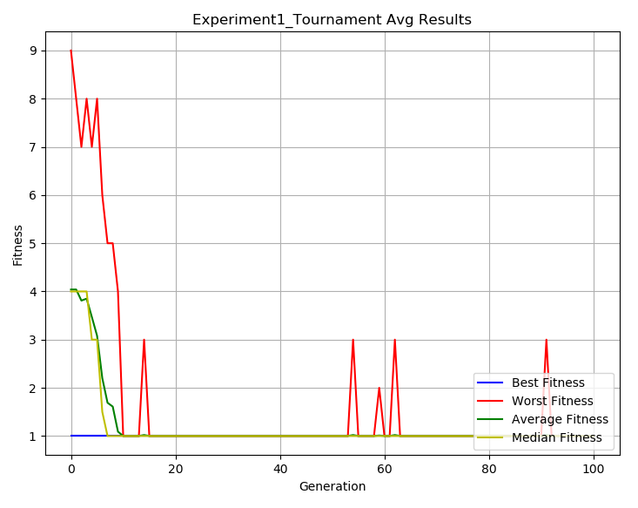Experiment 1:

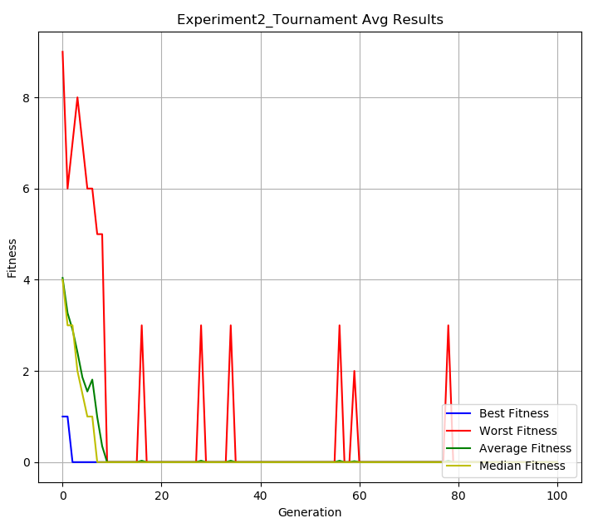Experiment 2:

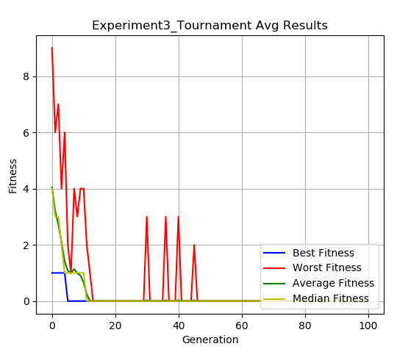

Experiment 3:

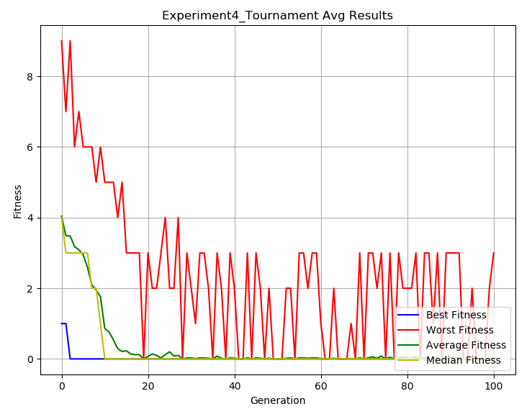Experiment 4:

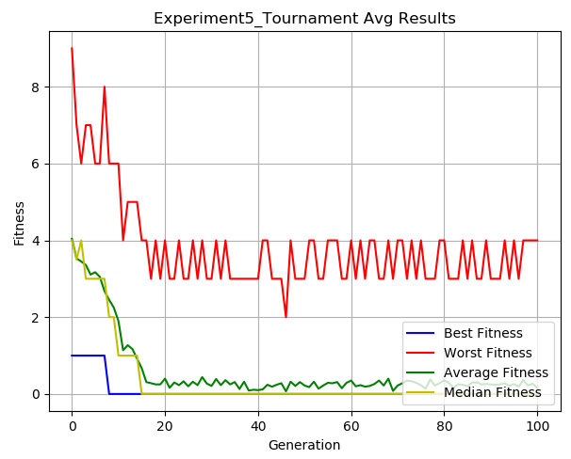Experiment 5: